**Brain Tumor Detection from EHR Using Artificial Neural Networks**

| V Karthick, Associate Professor *Department of CSE* *Rajalakshmi Engineering College* Chennai, India *vkarthick86@gmail.com* | Ukeshwaran G, UG Student  *Department of CSE*  *Rajalakshmi Engineering College* Chennai, India *210701295*@rajalakshmi.edu.in | Ayyappan A, UG Student  *Department of CSE*  *Rajalakshmi Engineering College* Chennai, India *210701510*@rajalakshmi.edu.in | Tharun Venkat V, UG Student  *Department of CSE*  *Rajalakshmi Engineering College* Chennai, India *210701289*@rajalakshmi.edu.in |
| --- | --- | --- | --- |

**Abstract— Early detection of brain tumors is crucial for proper treatment and improved patient care. The proposed system introduces a methodology employing artificial neural networks (ANN) to predict the presence of brain tumors based on scan reports. The objective of the system is to improve patient care by earlier detection of tumors and help medical professionals to make quick decisions. The Scan reports in csv format serves as the dataset, from which relevant features like radius mean, symmetry mean, concavity, fractal dimensions are extracted as inputs for the ANN model. The model utilizes sigmoidal function to predict the tumor and 250 neurons are used in each layer. Our proposed model has obtained an accuracy of 96 %.**

**Keywords**: Brain tumor prediction, Doctor reports, Artificial neural networks, neurons.

1. INTRODUCTION

Brain tumors pose a significant challenge in healthcare, emphasizing the critical need for early detection to enhance treatment efficiency. Traditional diagnostic methods primarily rely on medical imaging and expert interpretation, often resulting in delays in diagnosis and treatment initiation. Some methodologies provide a solution through CNN[1] However, recent advancements in artificial intelligence, particularly artificial neural networks (ANN)[2], offer promising prospects for improving brain tumor prediction.

Artificial neural networks are computational models inspired by the structure of the human brain's neurons, capable of learning intricate patterns from data. Utilizing ANN for brain tumor prediction involves training models on diverse datasets, typically comprising patient data, medical and clinical reports. By analyzing these inputs, ANN can find patterns indicating tumor presence, facilitating early detection.

The brain tumor prediction systems empowered by ANN can streamline diagnostic processes, reduce dependence on traditional diagnostic methods, and enhance diagnostic accuracy. Furthermore, it stresses the importance of integrating such systems into clinical practice[3] to improve healthcare professionals decision-making capabilities.

This project aims to explore the utilization of artificial neural networks in brain tumor prediction.

How the diagnostic methods that highly relay on expert interpretation can be streamlined so that detection can be done at the earliest thus improving patients care and helping medical professionals to make quick decisions.

1.1 Literature Review

Many researchers have proposed different methodologies for brain tumor detection using various machine learning techniques, the work done by D C Febrianto, I Soesanti , H A Nugroho[1] which is the base paper for our project performs image classification and uses CNN model to detect Brain tumor and has obtained an prediction accuracy of 93%. The work done by Ozyurt F, Sert E, Avci E, Dogantekin E[[4]](https://paperpile.com/c/CoB0Fb/9HlB) proposes a hybrid solution combining Neutrosophy and CNN, the performance of the system is evaluated against a SVM classifier and the solution provides an accuracy of 95.4%. The solution proposed by Selvi K, Sumaiya Begum a, Poonkuzhali P, Aarthi R[[5]](https://paperpile.com/c/CoB0Fb/0Vbc) implements a Dual Discriminator Conditional Generative Adversarial Network (DDCGAN) and the images from the dataset is proposed using Structural interval gradient filtering and the resulted model is evaluated and produces a accuracy of 93%.

The work done by Appiah, Helber Antonio, Cristiano Cabrera[[6]](https://paperpile.com/c/CoB0Fb/M50X) implements convolutional neural networks with proper orthogonal decomposition for identifying brain tumors efficiently and the resulting model has obtained a prediction accuracy of 95%. The work done by [A. Lumini, G. F. Roberto, L. A. Neves, A. S. Martins, and M. Z. do Nascimento,](http://paperpile.com/b/CoB0Fb/TLRo)  [[7]](https://paperpile.com/c/CoB0Fb/TLRo) propose a hybrid methodology combining both fractal geometry features and deep learning which tries to find the important spacial features in brain images, both original and the percolation image is fed as input for the CNN. In the work done by [M. S. Ullah, M. A. Khan,](http://paperpile.com/b/CoB0Fb/3i2y) [8] addresses an important issue in Computer Aided diagnosis(CAD) and proposes a convolutional network with Stack auto encoders along with a parallel pooling mechanism and achieves an accuracy rate of 94%.

The work by [V. Akoto-Adjepong, O. Appiah](http://paperpile.com/b/CoB0Fb/p4Jw) [9] propose a solution using a Capsule Network (CapsNets) called Tri Texton-Dense (TTDCapsNet) for recognising medical images and predicting brain tumor presence and the model achieves a accuracy rate of 94%. In the method proposed by [C. Ozdemir and Y. Dogan](http://paperpile.com/b/CoB0Fb/GcRQ)[10] uses a MTAP model along with Avg-TopK pooling method for extracting features from the images and the MTAP model achieves an accuracy of 95%.

1. MATERIALS AND METHODS

The dataset which is used in this project to train the ANN is doctors reports, the dataset is collected from The Cancer Imaging Archive(TCIA) which hosts a large set of medical reports[11] and cancer images[12]. The dataset consist of features of the tumor such as radius, texture, area, concavity, concave points and fractal dimensions. For each feature the mean and the worst value is recorded in the dataset. In total the dataset consists of 10 features and 5000 patients medical records which are separated into train and test datasets. The train set is used to train the ANN and a Sigmoidal function[13] is used as the activation function for predicting the output. The ANN consists of 250 neurons[14] in each layer and the model is trained for 1000 epochs and the trained model is validated against the test to find the accuracy of the system.

HARDWARE REQUIREMENTS

* A laptop or desktop computer with
* 8 GB RAM
* QUAD CORE PROCESSOR

SOFTWARE REQUIREMENTS

* Jupyter Notebook
* Python
* Web Browser(Chrome, Edge)

1. EXISTING SYSTEM

In the paper titled **“Convolutional Neural Network for Brain Tumor Detection”** by D C Febrianto, I Soesanti , H A Nugroho, in 2020 the proposed solution in this paper uses the MRI scan

Images as the dataset. The dataset consists of 253 images grouped into 2 groups, 155 brain images that have tumors, and 98 brain images that do not have tumors. The system uses these images to train the Convolutional Neural Network (CNN) which uses input images which are labeled as Yes/ No as raw data and tries to find patterns in these images. Based on the patterns learned from the training images the model detects the brain tumor. The system has a prediction accuracy of 93%.

1. PROPOSED SYSTEM

4.1 Dataset

Our proposed solution uses doctors' reports as the data set for training the CNN model. The dataset is collected from The Cancer Imaging Archive(TCIA) which hosts a large set of medical reports and cancer images. The dataset consist of features of the tumor such as radius, texture, area, concavity, concave points and fractal dimensions. In total the dataset consists of 10 features and 5000 patients medical records. The dataset is normalized[15] to prevent any feature from influencing the model's prediction. The following table displays the dataset classes.

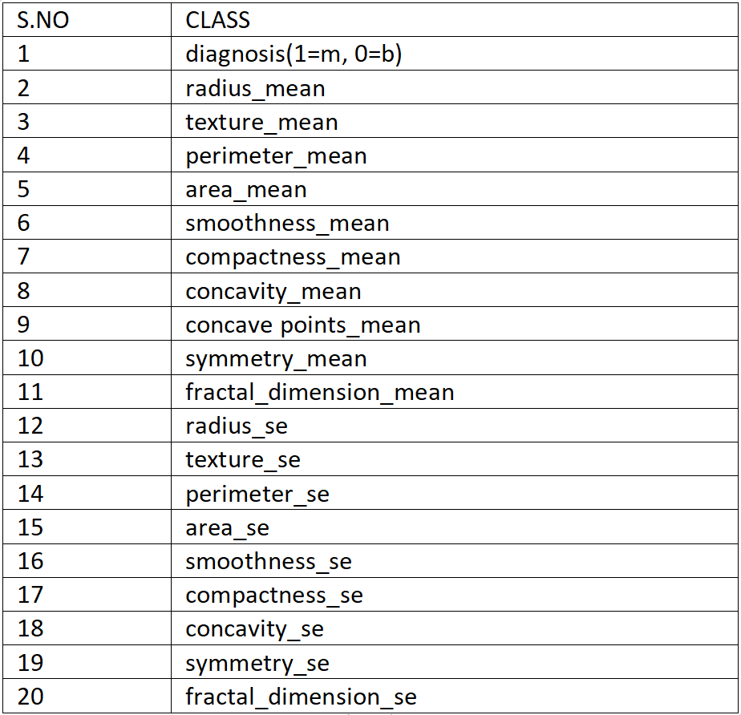

Table 4.1.1Doctors report dataset classes

4.2 Model Architecture

Our solution tries to overcome the challenges in traditional methods which are highly dependent on expert interpretation. In this proposed methodology we use ANN that learns patterns from the doctors report dataset which consist of 250 neurons and the model is trained for 1000 epochs. The trained model is used to predict the presence of brain tumor thereby supporting medical professionals in diagnosis and helps in earlier detection and decision making.

METHODOLOGY

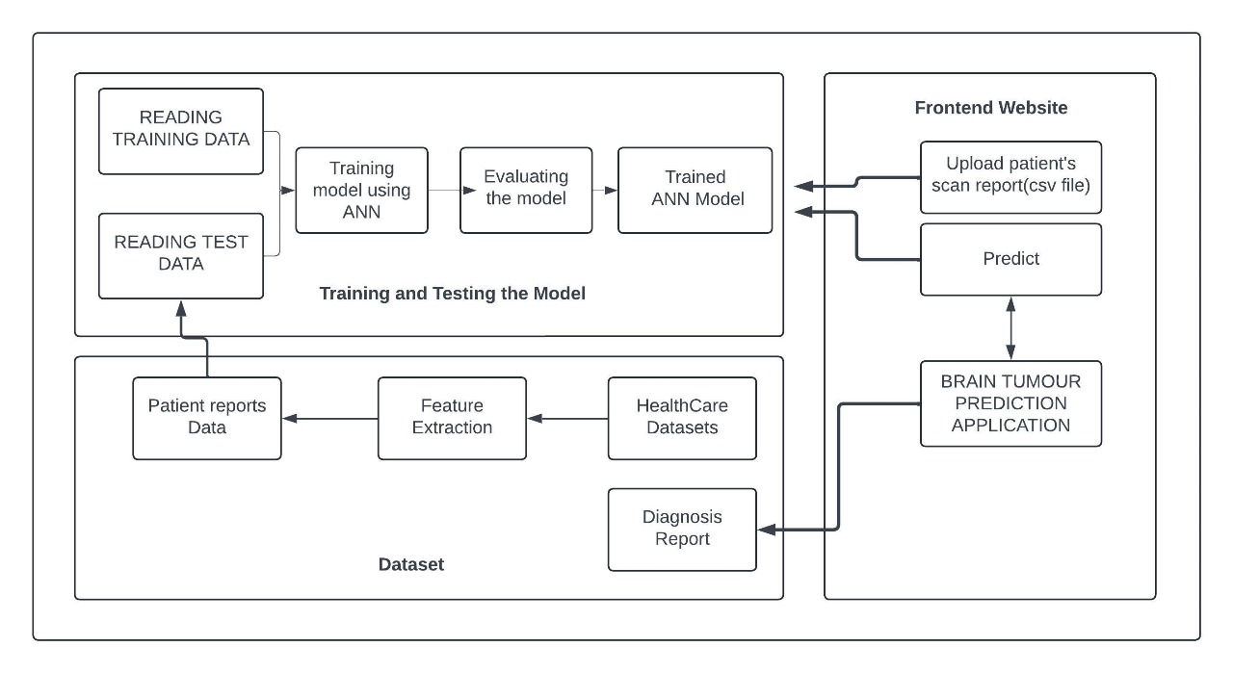 Figure 4.2.1 Architecture Diagram

4.3 Training and Testing

The dataset is splitted into train and test dataset in the ratio 80:20 and the ANN is trained in the labeled training dataset. The features such radius, texture, concavity and concavity points is taken as independent variables and the diagnosis feature is

taken as the dependent variable which indicates the presence of tumor. The sigmoidal function is used

as the activation function in the ANN model to predict the output. The trained model is tested against the test set and the corresponding accuracy of the system is determined.

**Number of training files : 4000**

**Number of test files : 1000**

V. RESULTS AND DISCUSSION

5.1 Confusion Matrix

The proposed model is evaluated and the confusion matrix for the trained model is attached in below figure 5.1.1

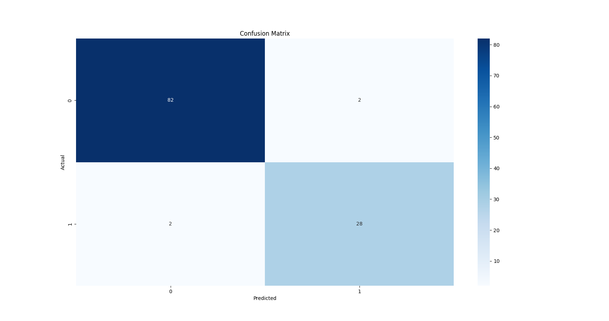

Figure 5.1.1 Confusion Matrix

5.2 Training and Testing Accuracy Graph

The ANN model is tested against the test data and the testing and training accuracy graph has been plotted. The training and testing accuracy of the model is plotted in the format of line graph with epochs in x-axis and accuracy in the y-axis,where the blue line indicates Training accuracy and the Red line indicates Testing accuracy in the below figure 5.2.1

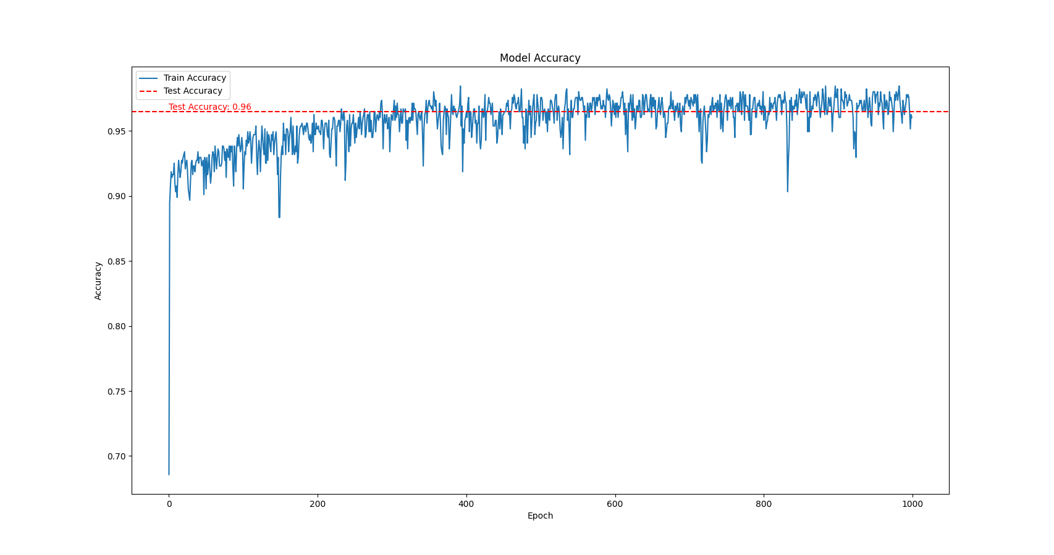

Figure 5.2.1 training and testing accuracy

VI. CONCLUSION

In conclusion, the brain tumor prediction system utilizing artificial neural networks (ANN) and from doctor reports as input, predicts the presence of tumor. .Comparing with prior models that utilized convolutional neural networks (CNN) for tumor detection and MRI images as primary datasets, which achieves an accuracy rate of 93%. Our solution which uses Artificial Neural Network (ANN) for tumor detection and doctors report as a dataset achieved an accuracy of 96%. The accuracy of the system can be increased by training the system with a larger number of neurons but it may also increase the time required for training the model. The features present in the dataset are also an another important factor which influences the models accuracy. This project tries to employ machine learning methodologies for early detection and diagnosis of brain tumors, ultimately leading to enhanced patient outcomes and healthcare delivery.

REFERENCE

[1] D C Febrianto, I Soesanti, H A Nugroho

Convolutional Neural Network for Brain

Tumor Detection , May 2020.

[2] [M. Rmus, T.-F. Pan, L. Xia, and A. G. E. Collins, “Artificial neural networks for model identification and parameter estimation in computational cognitive models,” May 2024.](http://paperpile.com/b/CoB0Fb/d3CJ)

[3] [K. K. Singh, M. Elhoseny, A. Singh, and A. A. Elngar, Machine Learning and the Internet of Medical Things in Healthcare. Academic Press, 2021.](http://paperpile.com/b/CoB0Fb/RZru)

[4] [F. Özyurt, E. Sert, E. Avci, and E. Dogantekin, Brain Tumor Detection Based on Convolutional Neural Network with Neutrosophic Expert Maximum Fuzzy Sure Entropy. Infinite Study.](http://paperpile.com/b/CoB0Fb/9HlB)

[5] [K. Selvi T, A. Sumaiya Begum, P. Poonkuzhali, and R. Aarthi, “Brain tumor classification for MRI images using dual-discriminator conditional generative adversarial network,” Apr. 2024.](http://paperpile.com/b/CoB0Fb/0Vbc)

[6] [R. Appiah et al., “Brain tumor detection using proper orthogonal decomposition integrated with deep learning networks,” Jun. 2024.](http://paperpile.com/b/CoB0Fb/M50X)

[7] [A. Lumini, G. F. Roberto, L. A. Neves, A. S. Martins, and M. Z. do Nascimento, “Percolation Images: Fractal Geometry Features for Brain Tumor Classification,”](http://paperpile.com/b/CoB0Fb/TLRo)

[8] [M. S. Ullah, M. A. Khan, N. A. Almujally, M. Alhaisoni, T. Akram, and M. Shabaz, “BrainNet: a fusion assisted novel optimal framework of residual blocks and stacked autoencoders for multimodal brain tumor classification,” Mar. 2024.](http://paperpile.com/b/CoB0Fb/3i2y)

[9] [V. Akoto-Adjepong, O. Appiah, P. K. Mensah, and P. Appiahene, “TTDCapsNet”: Tri Texton-Dense Capsule Network for complex and medical image recognition,” PLoS One, Mar. 2024.](http://paperpile.com/b/CoB0Fb/p4Jw)

[10] [C. Ozdemir and Y. Dogan, “Advancing brain tumor classification through MTAP model: an innovative approach in medical diagnostics,” Mar. 2024](http://paperpile.com/b/CoB0Fb/GcRQ).

[11] [A. Panesar, Machine Learning and AI for Healthcare: Big Data for Improved Health Outcomes. April, 2019.](http://paperpile.com/b/CoB0Fb/Yf0m)

[12] [Q.-M. Liao et al., “Multimodal neuroimaging network associated with executive function in adolescent major depressive disorder patients via cognition-guided magnetic resonance imaging fusion,” May 2024](http://paperpile.com/b/CoB0Fb/04LT).

[13] [J. C. Chang, X. Li, S. Xu, H.-R. Yao, J. Porcino, and C. C. Chow, “Gradient-flow adaptive importance sampling for Bayesian leave one out cross-validation for sigmoidal classification models,” Feb. 2024,](http://paperpile.com/b/CoB0Fb/spaV)

[14] [J. E. Dowling, Neurons and Networks: An Introduction to Neuroscience. Belknap Press, 1992.](http://paperpile.com/b/CoB0Fb/3bGA)

[15] Comparison of data preprocessing approaches for applying deep learning to human activity recognition in the context of industry 4.0-X Zheng, M Wang, J Ordieres-Meré - Sensors, 2018.